Olive, Lemon Zest, and Thyme
Mini-Muffin Recipe
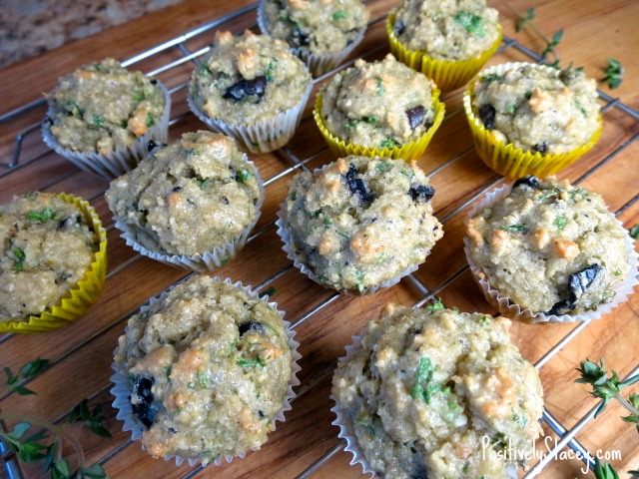
From The Healthy Mind by Rebecca Katz with Mat Edelson

INGREDIENTS:
- 2 cups almond meal
- 1/2 teaspoon sea salt
- 1/4 teaspoon freshly ground black pepper
- 1/2 teaspoon baking soda
- 3 large organic eggs
- 3 1/2 tablespoons extra- virgin olive oil
- 1 1/2 teaspoons lemon zest
- 1/2 tablespoon freshly squeezed lemon juice
- 1/2 tablespoon water
- 1 1/2 teaspoons Grade B maple syrup
- 12 kalalmata olives, chopped
- 1 tablespoon minced fresh thyme
- 6 tablespoons finely chopped parsley

DIRECTIONS
- Preheat the oven to 350 degrees. Line mini-muffin tin with muffin papers.
- In a bowl, mix together the almond meal, salt, pepper, and baking soda.
- In another bowl, whisk together the eggs, olive oil, lemon zest, lemon juice, water, and maple syrup.
- Add the wet ingredients to the dry ones and stir well to combine.
- Stir in the kalamata olives, thyme, and parsley.
- Fill each muffin cup with about 2 tablespoons of batter.
- Bake for 13 to 15 minutes, until a toothpick comes out clean.

