Cream Cheese Stuffed Bacon Wrapped Grilled Chicken

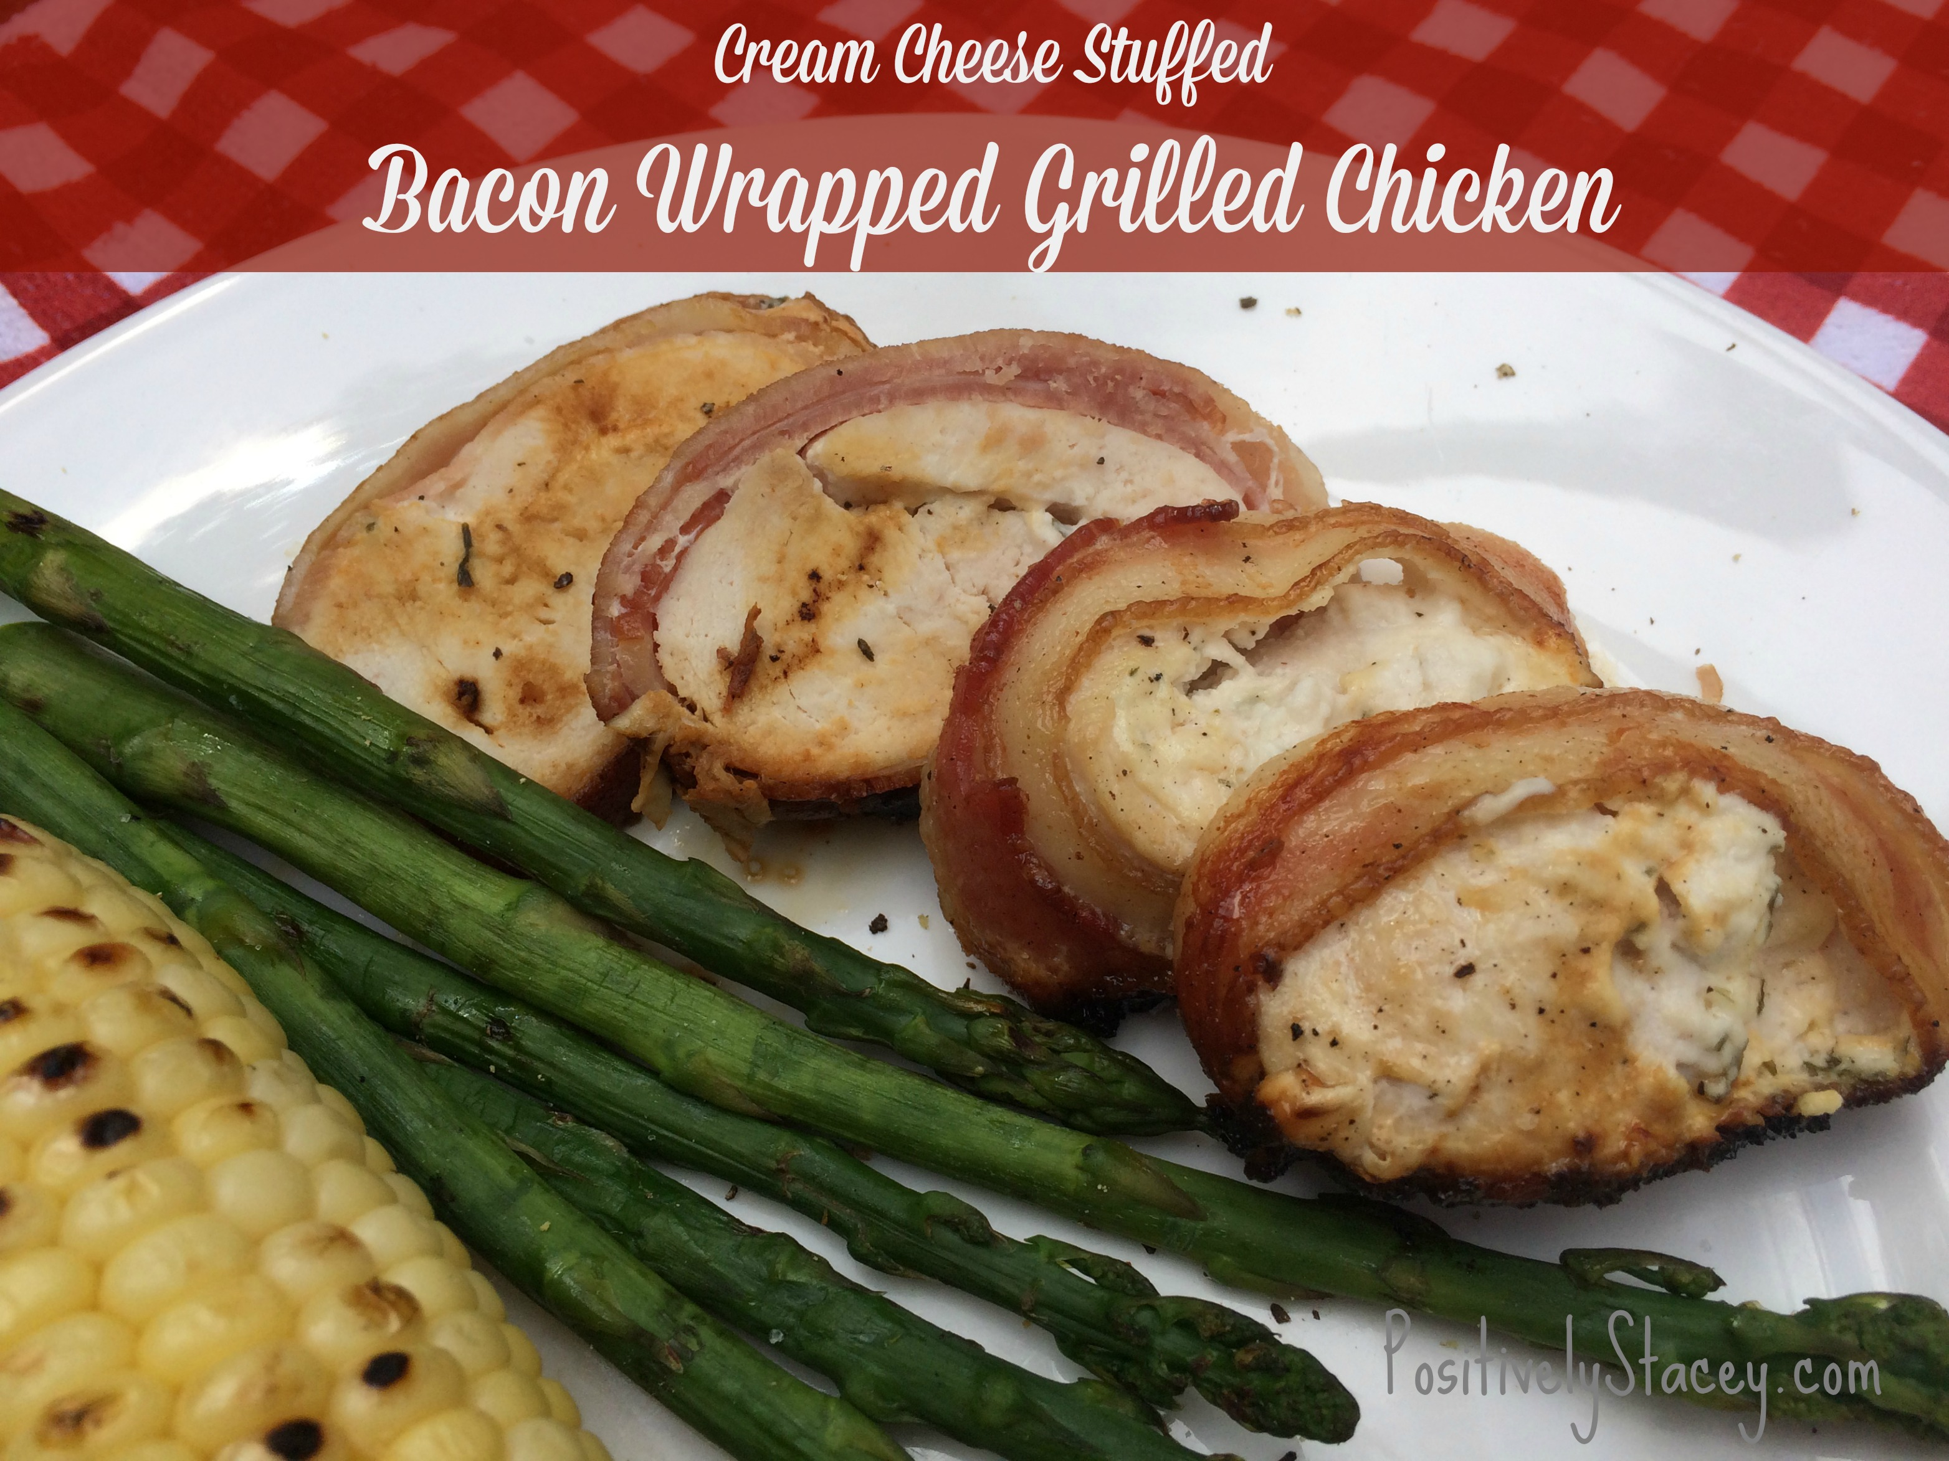

INGREDIENTS
- 4 whole boneless skinless chicken breasts, cut in half
- 1 pound bacon
- 12 oz. Garlic and Herb Cream Cheese
- 1 - tablespoons butter

DIRECTIONS
- Lay the chicken out and pound flat.
- Top each piece with large dollops of cream cheese
- Lay out a few (2 or 3) pieces of bacon, side by side
- Roll up chicken and place in center of bacon
- Wrap bacon up and around chicken rolls
- Set seam side down on foil covered cookie sheet
- At this point if you are making them ahead, cover with plastic wrap and place in the fridge until grilling time.
- Cover grill rack with foil. Heat grill to 400 degrees
- Pace chicken directly on foil and close grill. Let temperature settle down to 300 degrees.
- Grill for 30 minutes or until meat thermometer reads 165 degrees.
- Remove from grill. Let settle for five minutes, slice, and serve.

